Section I: Scenario Demographics

Scenario Title: | End of Life Care in the ED
Date of Development: | (08/12/2016) Revised (31/03/2018)
Target Learning Group: | Juniors (PGY 1–2) Seniors (PGY ≥ 3) All Groups

Section II: Scenario Developers

Scenario Developer(s): | Alexandra Stefan & Angela Stone
Affiliations/Institution(s): | University of Toronto
Contact E-mail (optional): | alexandra.stefan@utoronto.ca

Section III: Curriculum Integration

Objectives
Educational Goal: | Expose learners to the assessment and medical management of a palliative patient who presents to the emergency department with severe shortness of breath.
CRM Objectives: | - Communicate effectively with the patient, substitute decision maker and health care team during a critical clinical situation.  - Provide leadership to a team caring for a patient in extremis whose goals of care are not full resuscitation.
Medical Objectives: | - Verbalize and work through the causes of acute respiratory distress.  - Provide rapid symptom control treatment at the end of life.  - Communicate with patient and or substitute decision maker about the likely medical outcomes of various critical care interventions.

Case Summary: Brief Summary of Case Progression and Major Events
A 72-year old male with small cell lung cancer and bony metastases presents with acute shortness of breath. Curative treatment has been stopped and palliative care assessment is pending. He is on home oxygen and has come to the ED as his symptoms could not be controlled at home.

The patient initially improves with oxygen and pain control. He is too confused to engage in discussion about advanced directives. No previous advanced directives or level of care have been documented but, Cindy, the patient’s daughter is available to act as decision maker. She will have a number of questions about her father’s care.

The patient’s respiratory status will deteriorate. Cindy will confirm her father’s wish for comfort measures, to be started by the treating team.

Section IV: Scenario Script

A. Scenario Cast & Realism
Patient: | Computerized Mannequin |  |  |  |  | Realism:  Select most important dimension(s) |  |  | Conceptual
 | Mannequin |  |  |  |  |  |  |  | Physical
 | Standardized Patient |  |  |  |  |  |  |  | Emotional/Experiential
 | Hybrid |  |  |  |  |  |  |  | Other:
 | Task Trainer |  |  |  |  |  |  |  | N/A
Confederates | Brief Description of Role
Cindy | Daughter – Only child and substitute decision maker (SDM)/Power of Attorney (POA). Cindy and her father know the lung cancer has progressed and their oncologist has referred them to palliative care but they don’t have any prior experience with this and don’t know what it means. (Her medical literacy is below average.)  Her mother (patient’s wife) passed away in ICU 2 years ago after multiple admissions for CHF. The treatment was challenging and Mr. Clarke would not want this for himself.  Acts as SDM, wants interventions if “it will help”. On further questioning, she reveals that her father has said recently that he is tired of all the pain and does not want any painful procedures or “heroic measures”. Cindy is conflicted between wanting her father to live and following his wishes to avoid further interventions.  May be present at bedside or available on phone, depending on sim team availability.
B. Required Monitors
EKG Leads/Wires |  |  | Temperature Probe |  |  |  | Central Venous Line
NIBP Cuff |  |  | Defibrillator Pads |  |  |  | Capnography
Pulse Oximeter |  |  | Arterial Line |  |  |  | Other:
C. Required Equipment
Gloves |  |  | Nasal Prongs |  |  |  | Scalpel
Stethoscope |  |  | Venturi Mask |  |  |  | Tube Thoracostomy Kit
Defibrillator |  |  | Non-Rebreather Mask |  |  |  | Cricothyroidotomy Kit
IV Bags/Lines |  |  | Bag Valve Mask |  |  |  | Thoracotomy Kit
IV Push Medications |  |  | Laryngoscope |  |  |  | Central Line Kit
PO Tabs |  |  | Video Assisted Laryngoscope |  |  |  | Arterial Line Kit
Blood Products |  |  | ET Tubes |  |  |  | Other:
Intraosseous Set-up |  |  | LMA |  |  |  | Other:
D. Moulage
Elderly man wearing PJs.
E. Approximate Timing
Set-Up: |  | 5min |  | Scenario: | 12 min |  |  | Debriefing: |  | 15 min

Section V: Patient Data and Baseline State

A. Clinical Vignette: To Read Aloud at Beginning of Case
“Mr. Clarke is a 72 year old man from home with acute shortness of breath. He is in the resuscitation room. He has a history of lung cancer and is on 2L home oxygen. His daughter Cindy called 911 because he has been getting worse since this morning. He just finished a course of antibiotics for presumed pneumonia. He is on hydromorph contin and prochlorperazine. No allergies. Here is his most recent oncology clinic note.”
B. Patient Profile and History
Patient Name: Matt Clarke |  |  |  |  |  |  | Age: 72 |  |  |  |  |  |  | Wt: 60 kg
Gender: M F |  |  |  |  |  |  | Code Status: unknown
Chief Complaint: Acute Severe Shortness of breath
History of Presenting Illness: Since this morning patient has become more short of breath. His daughter found him struggling to breathe, cyanotic and not able to speak more than 1-2 words. He is acutely confused. She called 911, and EMS brought him to the hospital. He is also in significant pain from his metastases to his R femur and lumbar spine (missed pain meds at home).
Past Medical Hx: |  | - SCLC for 1.5 yrs, progression despite chemo and radiation  - Mets to bones – severe back and hip pain  - Home O2 (2L NP)  - Palliative Care consult pending |  |  |  |  |  | Meds: |  | - Hydromorph Contin 9 mg BID  - Hydromorph 2 mg breakthrough  - Prochlorperazine 5mg PRN  - Levofloxacin 750 mg – finished 5 days ago for pneumonia
Allergies: None
Social History: Lives at home with his daughter Cindy and her family
Family History: None
Review of Systems: |  |  | CNS: |  |  | Alert but confused, follows command
 |  |  | HEENT: |  |  | Lips look cyanotic
 |  |  | CVS: |  |  | Normal
 |  |  | RESP: |  |  | Resp distress, using accessory muscles, speaks 1-2 words
 |  |  | GI: |  |  | Normal
 |  |  | GU: |  |  | Normal
 |  |  | MSK: |  |  | Complains of leg and hip pain |  |  |  |  |  |  | INT: |  | Normal
C. Baseline Simulator State and Physical Exam
No Monitor Display |  |  |  |  | Monitor On, no data displayed |  |  |  |  |  |  | Monitor on Standard Display
HR: 120/min |  |  |  | BP: 130/80 |  |  |  | RR: 30/min |  |  |  |  |  |  | O₂SAT:84 % (4L NP)
Rhythm: Sinus |  |  |  | T: 36.8ºC |  |  |  | Glucose:7 mmol/L |  |  |  |  |  |  | GCS: 14 (E4 V4 M6)
General Status: Increased work of breathing, alert but confused
CNS: | Alert but confused.
HEENT: | Lips are cyanotic
CVS: | S1S2 no murmur, JVP is normal, no leg edema
RESP: | Decreased on right side, increased work of breathing, 1-2 works sentences due to dyspnea
ABDO: | Soft, tender
GU: | Normal
MSK: | Tenderness on palpation of right leg and hip |  |  |  |  |  |  |  | SKIN:
Section VI: Scenario Progression
Scenario States, Modifiers and Triggers
Patient State | Patient Status | Learner Actions, Modifiers & Triggers to Move to Next State
1. Baseline State  Rhythm: Sinus tach  HR: 120/min  BP: 130/80  RR: 30/min  O₂SAT:84 % (2L NP)  T: 36.8ºC | Sitting upright  Patient complains of hip and back pain. “My back…my hip. Need meds.” “It hurts.” “Can’t breathe.” All other responses: “don’t know” and “ask Cindy.” | Learner Actions  - History & physical  - IV, blood work, EKG  - Saline bolus  - Glucose check  - CXR  - Call RT  - Apply O2  - Team member to read clinic note | Modifiers  Changes to patient condition based on learner action  -Ask patient about his goals of care, he will say “ask Cindy”  Triggers  For progression to next state  -Read clinic note or 5 mins into the case 2. Stabilization
2. Stabilization  Rhythm: Sinus tach  HR: 110/min  BP: 140/90  RR: 24/min  O₂SAT:94% (NRB)  T: 36.8ºC |  | Learner Actions  - Try to find code status documentation  - POCUS for PCE, CHF, PNA and PTX  - Treat bone pain  - Call SDM | Modifiers  -Pain meds given HR 100  -If attempt intubation, daughter to arrive/phone asking for MD  Triggers  -Call POA or attempt intubation 3. Goals of Care Discussion
3. Goals of Care Discussion  Rhythm: Sinus tach  HR: 100/min  BP: 140/90  RR: 24/min  O₂SAT:92 % (NRM) | Cindy arrives or on the phone.  Asks about current status.  Wants to know prognosis and options.  Wants to know your recommendation. | Learner Actions  - Goals of care discussion with POA  - Call Oncology  - Call Palliative care | Modifiers  -Oncology/Palliative care will agree to see in ED in 30 min  Triggers  -All actions complete or 7 min into the case 4. Worsening resp status
4. Worsening Respiratory Status  Rhythm: Sinus tach  HR: 120/min  BP: 120/80  RR: 35/min  O₂SAT:86 % (NRB) | Patient complains of ongoing shortness of breath.  Cindy declines all interventions, wants father to be “comfortable”. | Learner Actions  - Ongoing goals of care discussion w/ POA  - Discuss Intubation  - Discuss BiPAP  - Discuss thoracentesis  - Recommend comfort measures | Modifiers  Triggers  -GoC discussion complete  5. Resolution
5. Resolution  Monitors shut off |  | Learner Actions  - Shut off monitors  - Order narcotic  - Order sedative  - Call SW/chaplain | Triggers  Oncology arrives End of Case

Section VII: Supporting Documents, Laboratory Results & Multimedia

Laboratory Results
Critical VBG | pH: 7.22 | PCO₂: 65 | PO₂: 45 | HCO₃:28 | Lactate:2.5

Images (ECGs, CXRs, etc.)
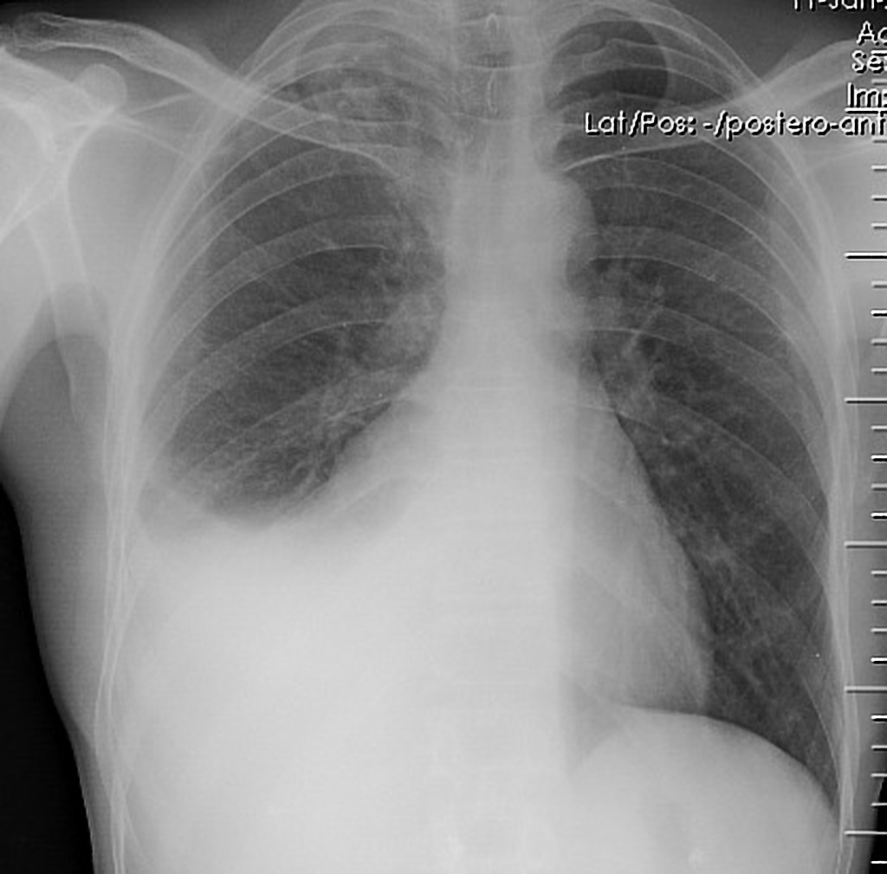  https://radiopaedia.org/cases/pleural-effusion-7 | EKG: Sinus tachycardia  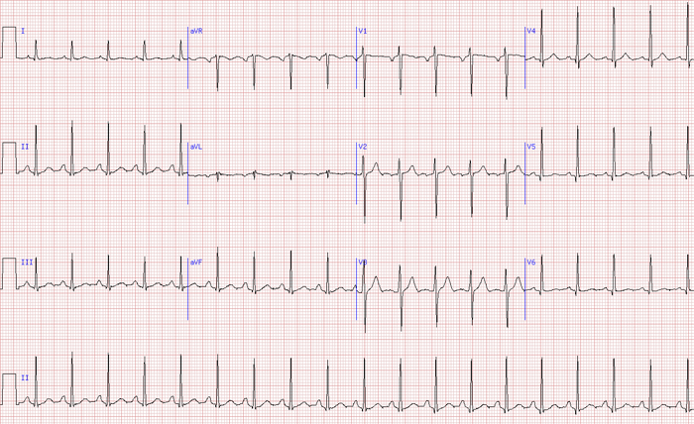  http://www.thecrashcart.org/case-2-post-partum-palpitations/
Ultrasound Video Files (if applicable)
Ultrasound: Right pleural effusion | Ultrasound: No pericardial effusion

Section VIII: Debriefing Guide

General Debriefing Plan
Individual |  | Group | With Video | Without Video
Objectives
Educational Goal: | Expose learners to the assessment and medical management of a palliative patient who presents to the emergency department with severe shortness of breath
CRM Objectives: | - Communicate effectively with the patient, substitute decision maker and health care team during a critical clinical situation.  - Provide leadership to a team caring for a patient in extremis whose goals of care are not full resuscitation.
Medical Objectives: | - Verbalize and work through the causes of acute respiratory distress.  - Provide rapid symptom control treatment at the end of life.  - Communication with patient and or substitute decision maker about the likely medical outcomes of various critical care interventions.
Sample Questions for Debriefing
Medical Knowledge
- Describe your differential diagnosis for acute respiratory distress. How does this change in an oncology patient?
- What are the bedside diagnostic tools for acute respiratory distress?
- What are common end-of-life symptoms that are distressful to patients and families? How do we treat them in the ED?
- How do you determine a patient’s competence? What is the hierarchy of SDMs?

CRM Skills
- What is your approach to goals of care discussions in the ED? How do you modify this over the phone vs in person? Or if time is short because of the clinical situation?
- What language do you use to explain critical care interventions to non-medical family members?
- What resources can you use when facing an uncertainty in code status?
- What are some tools to help navigate conflict regarding treatment decisions within the medical team?

Key Moments
Establishing the patient’s significant past medical history
Determining the patient’s level of competence and contacting the substitute decision maker
Goals of care discussion with SDM
Transitioning clinical management to comfort measures

References
Marx, J. A., Hockberger, R. S., Walls, R. M., & Adams, J. (2013). Rosen's emergency medicine: Concepts and clinical practice. St. Louis: Mosby.
Helman A.(2015). End of life care in emergency medicine. EMCases.com.
https://emergencymedicinecases.com/end-of-life-care-in-emergency-medicine/
Mierendorf S & Gidvani V. (2014). Palliative Care in the Emergency Department. Perm J. 18(2): 77–85.
https://www.ncbi.nlm.nih.gov/pmc/articles/PMC4022562/

